FALL/WINTER APPAREL ORDER

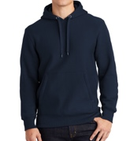
Heavy Hoody - $47
https://www.sanmar.com/p/2777_AthlHthr#?doScrollToGrid=true

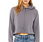

Cropped Hoody - $42
https://www.bellacanvas.com/product/7502/Womens-Cropped-Fleece-Hoodie.html

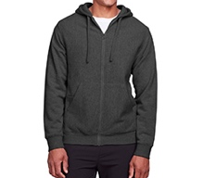

Heavy Zip Up - $45
https://www.alphabroder.com/cgi-bin/online/webshr/prod-labeldtl.w?sr=TT95&currentColor=RJ

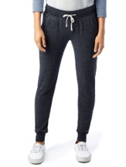
Fashion Joggers (Men & Women’s cut available) - $44
Women’s:
https://www.alphabroder.com/cgi-bin/online/webshr/prod-labeldtl.w?sr=31082F&currentColor=07
Men’s:
https://www.alphabroder.com/cgi-bin/online/webshr/prod-labeldtl.w?sr=09881F&currentColor=CY

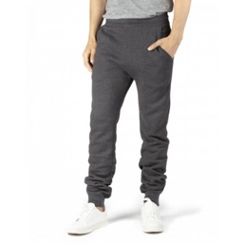

Joggers (zip ankle) - $39
https://www.alphabroder.com/cgi-bin/online/webshr/prod-labeldtl.w?sr=320P&currentColor=06

Baseball Hat - $26
https://www.alphabroder.com/cgi-bin/online/webshr/prod-labeldtl.w?sr=6245CM&currentColor=20

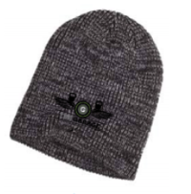

Winter Hat - $26
https://www.alphabroder.com/cgi-bin/online/webshr/prod-labeldtl.w?sr=BA524&currentColor=60

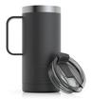
RTIC travel mug - $29
laser, stainless steel engraving

→ NAME:
 | SIZE | COLOR | GRAPHIC | PRICE
HEAVY  HOODY | Circle one:  S M L  XL 2XL 3XL | Color (write in):  ____________  *color options in link  *Be sure to think about how the logo will look printed on that color* | Circle one:  Garage Train  Bolts CrossFit  *printed on front | $48 | Punch Card:  Y/N  Total cost:
CROPPED  HOODY | Circle one:  S M L  XL 2XL 3XL | Color (write in):  ____________  *color options in link  *Be sure to think about how the logo will look printed on that color* | Circle one:  Garage Train  Bolts CrossFit  *printed on front | $42 | Punch Card:  Y/N  Total cost:
HEAVY  ZIP UP | Circle one:  XS S M L  XL 2XL 3XL | Color (write in):  ____________  *color options in link  *Be sure to think about how the logo will look printed on that color* | Circle one:  Garage Train  Bolts CrossFit  *printed on back | $44 | Punch Card:  Y/N  Total cost:
JOGGERS  (Zip Ankle) | Circle one:  XS S M L  XL 2XL 3XL | Circle One:  Black Dark Grey  Light Grey | ONE  GRAPHIC  (embroidered) | $39 | Punch Card:  Y/N  Total cost:
FASHION JOGGERS  (MEN CUT) | Circle one:  XS S M L  XL 2XL 3XL | Color (write in):  ____________  *color options in link | ONE  GRAPHIC  (embroidered) | $44 | Punch Card:  Y/N  Total cost:
FASHION JOGGERS  (WOMEN CUT) | Circle one:  XS S M L  XL 2XL 3XL | Color (write in):  ____________  *color options in link | ONE  GRAPHIC  (embroidered) | $44 | Punch Card:  Y/N  Total cost:
BASEBALL  HAT | ONE SIZE | Color (write in):  ____________  *color options in link  *Logo will be printed in black | GARAGE  GRAPHIC  (embroidered  in black) | $26 | Punch Card:  Y/N  Total cost:
WINTER  HAT | ONE SIZE | Circle One:  Black Maroon  Navy Olive | GARAGE  LOGO  (embroidered  in black) | $26 | Punch Card:  Y/N  Total cost:
RTIC INSULATED  TRAVEL MUG | ONE SIZE | ONE COLOR  (charcoal) | GARAGE  LOGO  (laser engraving  stainless steel) | $29 | Punch Card:  Y/N  Total cost:

TOTAL PUNCH CARDS RECEIVED: __________ TOTAL DUE: _____________ PAYING BY:(circle one): CASH CHECK ZEN PLANNER
GRAPHIC OPTIONS:

GARAGE

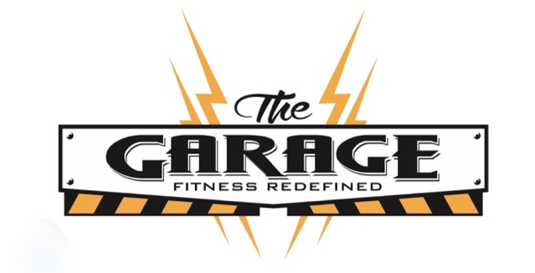
CROSSFIT
BOLTS
TRAIN

